Team 1 Open Source Air Quality Monitoring

Week 10: March 6th 2022 - March 12th 2022

Sponsor: Dr. [David Burnett](mailto:dburnett@pdx.edu)

Advisor: Dr. John Acken

Team Members: [Adam Dezay](mailto:adezay@pdx.edu), [Manuel Garcia](mailto:manga2@pdx.edu), [Brandon Hippe](mailto:bhippe@pdx.edu), Mercedes Newton

**Team Review:**

* After extensive feedback from both our advisor and industry sponsor, our team has dedicated additional focus on clear documentation.
* All team members are connecting to and coding in Energia.
* Team members are each working on specified sensor/component tasks.
* Enhanced gantt chart as shown in figures 1-4.
* Moved team meetings to better accommodate schedules.
  + New times, effective immediately are Monday @ 4:30pm, Tuesday @ 7:30pm, Thursday @ 7:30pm .
* Team discussed changing meeting time with Dr. Acken for the upcoming term
  + Potential advisor meeting times that work for the team: Thursday @2-4pm or Friday at 8am, set to be discussed during Monday meeting on 3/13/2023.
  + Starting april 6, 3pm meetings.

**Individual Review**

Due to recent sponsor and advisor feedback, we have produced a more detailed description of individual progress and current roadblocks.

Adam Dezay: CO2 sensor updates - working on connecting CO2 sensors to Energia. Having issue getting I2C to work, following previous years example, yet to have success connecting using msp430 and energia. Spent around 8 hours this week troubleshooting code, finding and importing libraries, will update when progress has been made.

Manuel Garcia: Attempted to get both Smartmesh and I2C working on the MSP430. Worked more on getting specific sensors into our KiCad schematic.

SMARTMESH - able to power on a node and connect it to the host PC via coin cell power and software from analog devices. Unable to communicate with the board or power it on via power pins, Also unable to get the previous years python gui to run, suspected issues with libraries and python being different versions, need to either spend time updating code to current libraries, re-write the application to better fit our needs, or try and locate all outdated zip files of old project in order to get running. I have found that the documentation for the smartmesh system has been far less comprehensive than I was hoping for, I am not sure if I am just looking in the wrong places, however after several day long attempts I have not had success getting it to work or finding documentation on how exactly it should be set up for our purposes.

ENERGIA & MSP430 - Having issues with working with Energia and the MSP430, getting to the point where I might switch to code composer studio and re-write the whole project in C. Right now an error I get almost every time I turn on the energia IDE requires that I delete the whole “Energia15” folder from my %appdata% and reinstall it, I have not found a workaround for this. Deleting this folder has been a nuisance, however has been doable since it does not delete the code I have written. This however changes now that we are using I2C to communicate with our sensors and the smartmesh boards. I looked into how the previous year was able to use I2C and they showed how they needed to edit several files and values in the “Energia15” folder in order to get their code to run. We have not successfully re-done what they have shown because their documentation is for a different msp430 than we are using with a different pinout and chip, and the edits they made are chip specific. On Top of needing to do the work of editing these files in order to get I2C to work for our chipset, when I get this daily error requiring me to delete this subfolder I will also need to go back and make the same 20 or so code edits in order to program the IDE to work with our MSP430fr2355 chip. I also have not found good documentation on doing this online and would have to reverse engineer what last year's capstone team did and hope that with enough edits and iterations that it would work for our chip. This has led me to further consider using code composer studio because all of the official documentation from TI, as well as any other reputable source, uses code composer studio and the C language. This would require a severe overhaul of our code and take a significant amount of time to do, however I believe it would lead to more reliable and reproducible code for ourselves and any future team that was interested in continuing on with this project.

Brandon Hippe:

Anemometer updates - UART communication with both sensors is inconsistent. Each one works individually, but both don’t work simultaneously. I’ve been trying to use the same transmit pin for both so that they trigger at the same time, but I’ll have to try to get them both working separately but at the same time before trying again. Otherwise, could use the pulse duration mode, but it seemed to be very inconsistently responding to airflow.

Mercedes Newton:

PM2.5 sensor updates - Working on connecting PM2.5 sensor to Energia and producing working code. Experiencing difficulty updating sensor libraries from arduino to Energia. Currently reviewing last year’s capstone documentation and attempting to model the switch after last year’s team. Exerting new focus on documentation in order to update advisor and sponsor on team progress.

**Gantt Chart and Timeline Updates:**

Below is both the general timeline of the project as a whole as well as a breakdown of the specific tasks that are left moving forward. Due to delay in selecting and receiving sensors, as well as team difficulty in implementing them, we have postponed several of our due dates to better reflect our progress. Additionally, we have switched our gantt chart format from Excel to Google Sheets to make editing more efficient and legible. All gantt charts are representative of the timeline for this term only. In the week eleven report we intend to have an updated timeline for spring term.

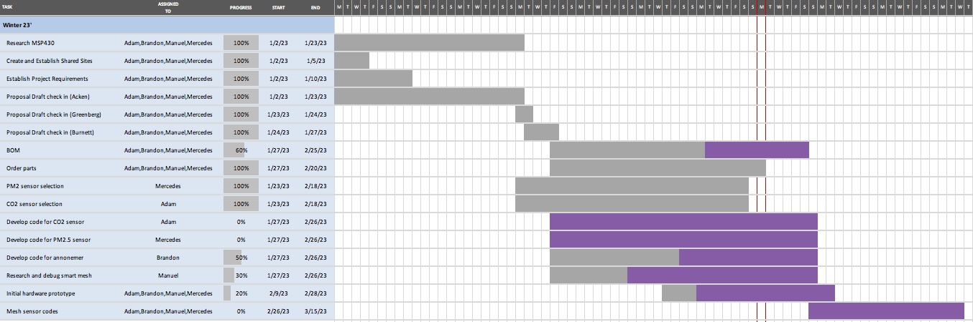

Figure 1: Original Gantt chart as seen on project proposal

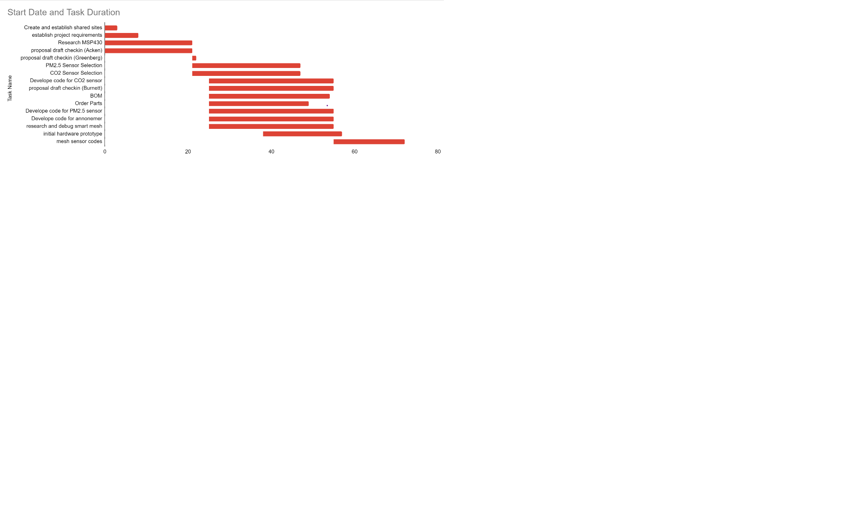

Figure two: Original gantt chart remade in Google Sheets

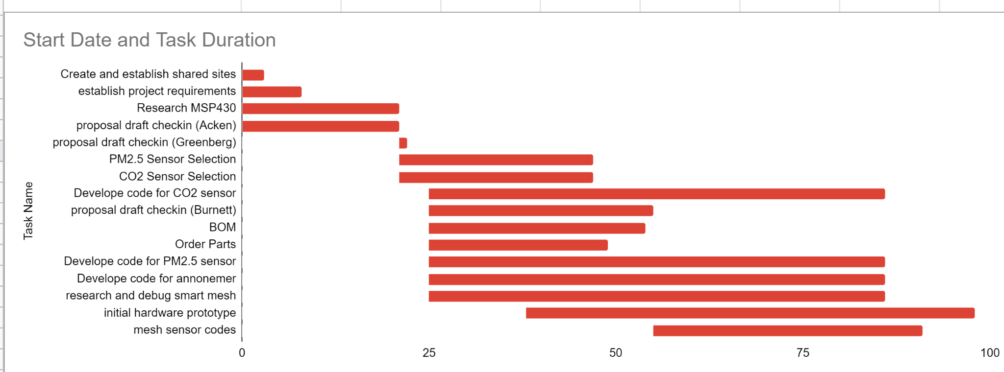

Figure three: New gantt chart with updated deadlines

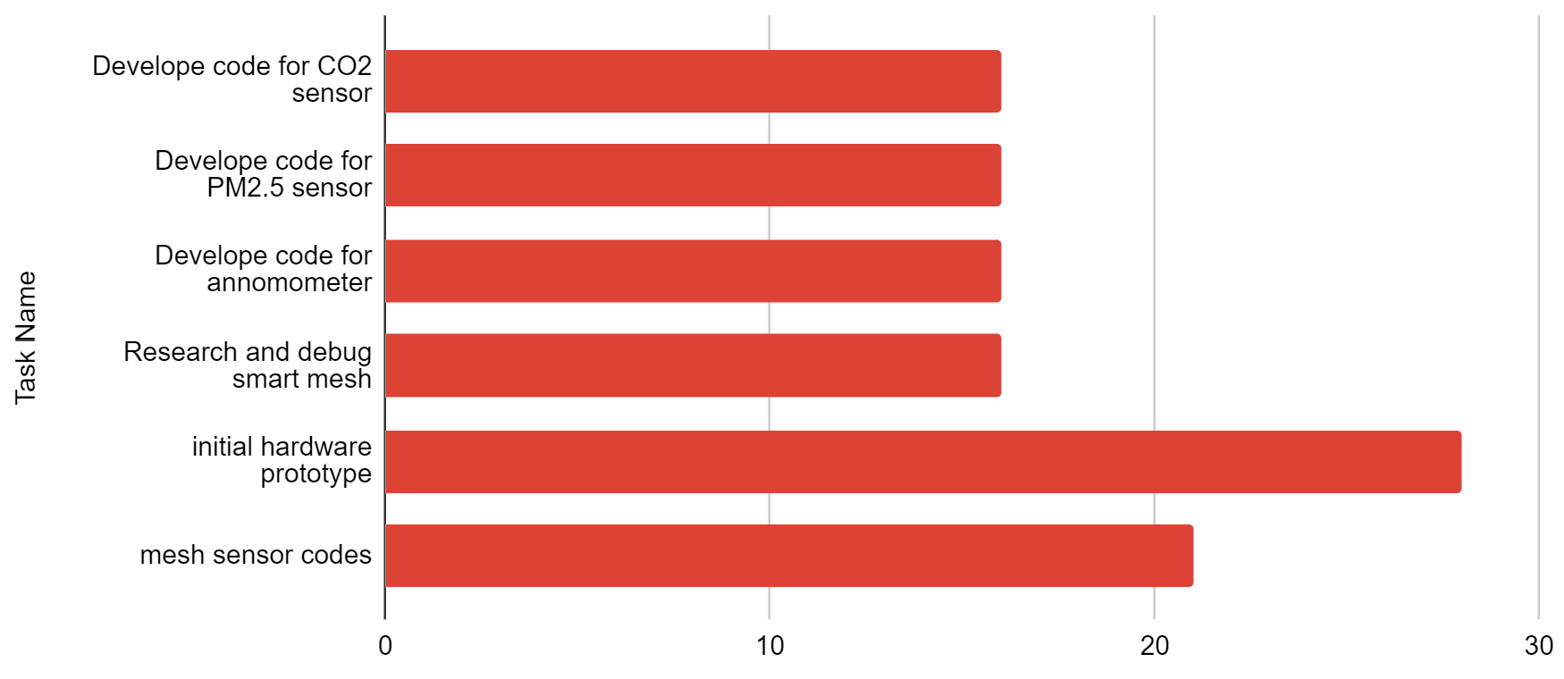

Figure four: Pending tasks with updated finishing dates in relation to current date 3/13/2023

| Task Name | Expected Completion Date |
| --- | --- |
| Develop code for CO2 sensor | 3/29/23 |
| Develop code for PM2.5 sensor | 3/29/23 |
| Develop code for anemometer | 3/29/23 |
| Research and debug smart mesh | 3/29/23 |
| initial hardware prototype | 4/10/23 |
| mesh sensor codes | 4/3/23 |

Table 1: current tasks with updated expected completion dates

**KiCad:**

Current Top-Level Kicad schematic, filling in internal subsheets with components and wires as we figure out what we need. Will post sub level schematics as we make progress in future reports.

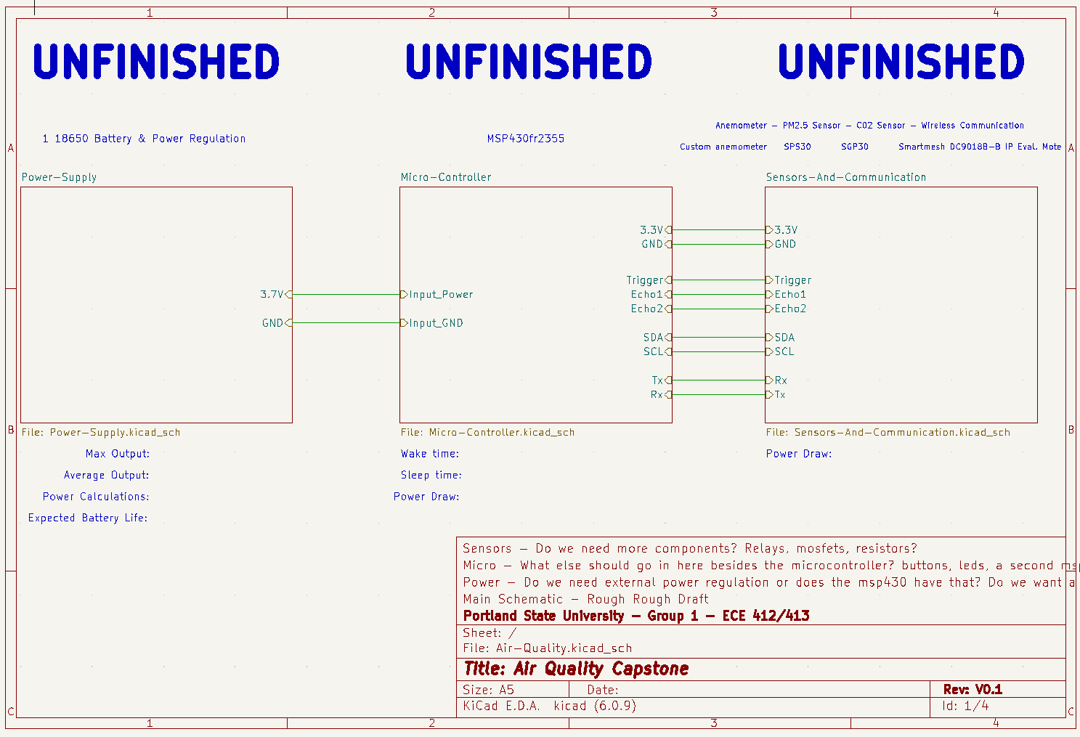

Figure Five: Top level KiCad Schematic